Even the Queen doe not need DipTac Low floor cars!

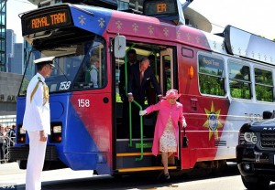
The Queen and Prince Philip are seen alighting from the specially prepared Melbourne tram 158 at the end of their historic tram ride.
Photo courtesy of Buckingham Palace News.
http://www.guardian.co.uk/uk/video/2011/oct/26/queen-royal-tram-melbourne-australia-video?newsfeed=true

